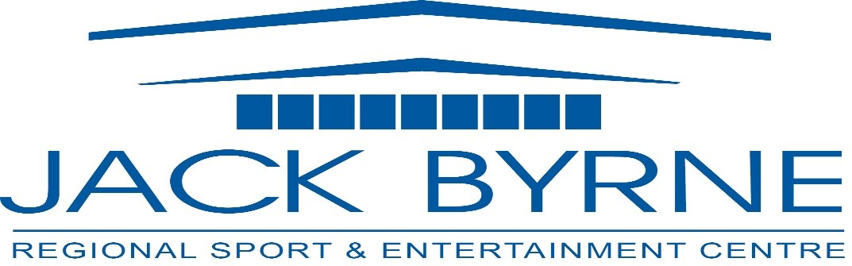

Minutes
JBR Board of Directors Meeting
October 24, 2024

Attendance: Mark Vardy, Rhonda Manning, David Hearn, Tony Pollard, Shannon Power, Laurie Furlong
Regrets: Darrin Thorne, Brian Martin, Tony Palmer, Christopher Roche

- Call to Order 7:22pm
- Minutes of Previous Meeting (June 13,2024)
  - Errors/ Omissions – none noted
  - Adoption of Minutes – Tony moved, Shannon seconded
  - Business Arising
    - Strategic Plan Review
      - Asking board to review and email comments by Nov. 30 to Cathy
    - CRA Update – no update
- Financials to September 2024 – Tony presented, no concerns noted
    - Tony moved to accept financial report, Shannon seconded
  - Proposed Budget 2025
    - Tony presented proposed budget, all in agreement
    - Laurie moved to accept proposed budget, Tony seconded, accepted
- Operational Update:
New season of activity in full swing.
Repair and maintenance of the facility is 90% complete, with a couple of small projects to be finished up in November.
Minor hockey and Junior hockey have both started their season; with hopes of larger spectator crowds, the home games will be played on Saturday evenings. High School hockey will take their place on Sundays and we picked up a Tier 2 Holy Trinity team this year filling in schedule gaps. Senior Hockey will begin on November 1st.
Two Christmas Craft markets scheduled for November, the combined revenue for these shows will be approximately $74,000.
Applied for and received funding in the amount of $1840.00 through the Active Living Fund. This funding allowed us to continue our walking program and expand it slightly, bringing more community residents into our building.

Maintenance Update: including facility painting, repairs to parking lot, shower rooms, electrical, and dehumidifier
Zamboni repairs
Installation of folding gate in bar to create ‘warming area’
Bluetooth receiver has been attached to the sound panel

Event Update: Two special events on the schedule for November.

Budgeting for Future Repairs
As the building ages, we can anticipate some very costly repairs in the coming years. For information purposes, I have compiled a list with an approximate cost for each.
HVAC, Bio Green, Lighting, Condensor and Compressors

Applied for funding through the Green & Inclusive Community Buildings Fund, in the amount of $1.3 million. The application included all of the work listed above, as well as some additional wish list items. All of these improvements would lead to a more inclusive and energy efficient facility.

Other maintenance that hasn’t been included the roof over the community room (front window overlooking parking lot), the main surface of the roof, the steel beams over the ice surface and the parking lot. Over the summer, we were able to fill in several small potholes but it was noted that there is a crack running the length of the parking lot that will potentially cause issues in the future.

Jack Byrne Regional was nominated and selected as the recipient of the Innovation Award for the 2024 takeCharge Luminary Awards.

Quotes to be obtained for cost of having roof assessed

Report moved by Shannon, seconded by Tony
- Tony will work with Cathy to put long term numbers in place

- Other Business
- Meeting Adjournment – 7:54 pm Shannon moved, Laurie seconded

Next Meeting: January 23, 2025

