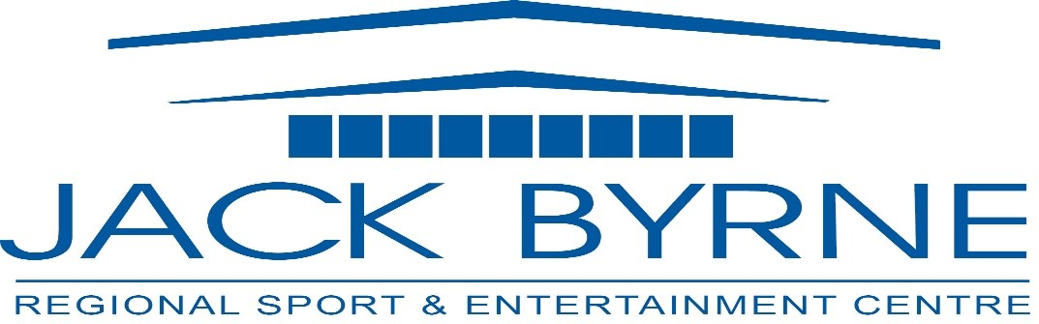
Minutes
JBR Board of Directors Meeting
June 13, 2024

Attendance: Mark Vardy, Rhonda Manning, David Hearn, Tony Pollard, Christopher Roche, Tony Palmer, Darrin Thorne, Terry Humber, Shannon Power

- Call to Order 7:04 PM
- Presentation: North East Minor Hockey
- Minutes of Previous Meeting (March 7,2024)
  - Errors/ Omissions- None noted
  - Adoption of Minutes: Motion to accept, Tony, seconded Rhonda
  - Business Arising
    - Strategic Plan Review & Adoption – Moved to re-evaluate, did not approve
    - CRA Update- No update
- Financials to May 2024- Tony presented, no concerns noted
- Operational Update:

Maintenance Update

The following maintenance has been completed:

HVAC system-
All repairs have been completed $4615.00
Martins-
Fire Extinguisher & Sprinkler System $2440.00
CIMCO-
Oil change in both compressors
Overhaul was required due to unusual wear in one compressor

Building Repairs
- Community Room repairs and painting complete
- Outside Community Room wall (track side) in progress
- Hallway under bleachers complete
- Dressing room 3 & 4 complete
- Dressing room 5 complete
- Dressing room 1 complete

To be completed:
- Dressing room showers
- Main hallway
- Foyer
- Canteen cleaning

Additional Notes

A new set of hockey nets was ordered and are on the way! The old ones were welded several times last year. They will be kept as practice nets.
A couple of pieces of dasher board and kick plate are also on the way to replace damaged pieces.

We had a visit from the new Fire Inspector (Torbay Volunteer Fire Department). He went through the facility with David and submitted a report. There were a few deficiencies noted, most corrective actions have been completed.

Event Update

The following events have taken place.
Atlantic Grocery – 2 day tradeshow (4 day rental) *booked for 2025
Mega Market- 1 day market *booked for 2025
NL Construction Expo- 2 day event (4 day rental)
Holy Trinity Prom
MUN Engineering Dinner & Dance *booked for 2025
Pub Night – 4 local bands; most successful to date
College of North Atlantic Cap & Gown- 2 day event (3 day rental)

The next week will continue with special events. We have Milestone Learning Centre (Preschool) graduation, Learning Tree (Preschool) graduation, Holy Heart Prom, and to bring the off season to a close we have Holy Trinity High and Gonzaga High Cap & Gown ceremonies.

Staff will begin the ice making process on Friday, June 21st with our first rental scheduled for Friday, June 28th.
Our summer schedule is booking up quickly. We have confirmed over 300 hours for July.

Vision Hockey 78.5 hours
Prince of Wales Skating Club 118 hours
Danny Cleary Hockey 65 hours
Other 61.5 hours

August is expected to be equally busy.

Rental Rates

I am proposing a rate increase of $5.00 per hour on all ice rental rates.
The increase would look like this:
Prime $290.00 ($252.17 + tax)
Daytime $225.00 ($195.65 + tax)
NEM/ PWSC $260.00/ $290.00 ($226.09/ $252.17 + tax)
School $225.00 ($195.65 + tax)

High School Ice Time Request

With the change in school opening/ closing times for 2024- 2025 for Holy Trinity High School, they will no longer be able to use 3:00pm- 4:00pm for practice on Monday, Tuesday and Wednesday.
They have requested a move to 4:00m- 5:00pm on these days.
3:00pm on Tuesdays could be used by Juniper Ridge Intermediate (whose opening/ closing time will also be changing)

This past season, Minor Hockey returned 4:00pm on Mondays and Wednesdays.

Minor Hockey Ice Time Request

Minor Hockey requested the following:
Monday, additional ½ hour earlier
Tuesday, additional ½ hour later - potential to loose last group of the evening
Wednesday, additional ½ hour later
Friday, additional ½ hour later- push Senior hockey game to 8:00pm start

**last season, the first rental on Saturday and Sunday was 7:30am; I would propose an earlier start for 6:30am (as in previous years). This would provide the additional time request, without losing other rental groups.

- Ice Rental Rates 2024-2025 Season- Slight Increase approved by all as presented in operations report
- Request for Ice Time- Holy Trinity High School- Reviewed and approved.
- Contract Renewal- Manager- Discussion ensued, contract to be offered to Cathy and updated.
- Other Business- David Hearn will be taking over the secretary role effective next meeting in October

- Meeting Adjournment 8:26 PM

Next Meeting: September 19th

