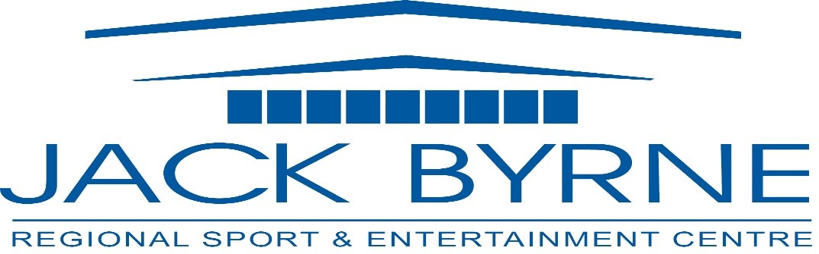
Minutes
JBR Board of Directors Meeting
January 30, 2025

Attendance: Mark Vardy, Tony Pollard, David Hearn, Shannon Power, Brian Martin

- Call to Order 7:02
- Minutes of Previous Meeting (October 24,2024)
  - Errors/ Omissions
  - Adoption of Minutes (Tony moved, Shannon seconded)
  - Business Arising
    - Strategic Plan – discussion on implementation, costs and sharing expenses, discussion on forming committees for organizing, facilitating events at JBA
    - CRA Update – no update
- Financials to December 2024
- PFAS Testing
  - Discussion on PFAS levels – levels are within acceptable limits since last testing
  - Discussion on next steps – further testing to ensure limits are within acceptable
  - Motion – Board to contact Town to request further testing of water for PFAS levels from TC (moved by Tony, seconded by Brian)
- Operational Update – report attached
  - Discussion on reinvesting GIC – cashflow analysis then decide
- 2025 AGM Meeting Date – April 10, 2025 – AGM and Board Meeting
- 2025 Board Meeting Schedule
- Other Business
  - Cathy discussed upcoming Frosty 5K event at arena
  - Brian discussed potential purchase of adjacent land
  - Tony raised issue of fire pond / dry hydrant which is low/dry
- Meeting Adjournment -

OPERATIONAL UPDATE
January 2025

Maintenance Update (October - December 2024)
Over the past three months, several important repair and maintenance tasks were completed:
- Hydraulic Motor for Zamboni: A new hydraulic motor was purchased for the Zamboni at a cost of $2,400.00.
- Auger Purchase: An auger was bought for $4,600.00. The damaged auger was repaired and will be kept as a spare.
Some of the repairs to the Zamboni have been caused by human error, however several are being processed as warranty through Saunders Equipment.
- Auto-Clean Units Installed in Female Washrooms: These installations have significantly improved the cleanliness of the washrooms. The cost of the units was a one-time charge, maintenance is covered under the Pest Control Contract.
- Exterior Lighting: 12 new lights were purchased and installed around the building's perimeter for $750. There are three that are currently not working, as they require new ballasts.
- Lock and Key Replacement: Replacement of locks and keys for dressing rooms continued, with a cost of $500. This process will total around $1,400 annually due to frequent issues with broken or lost keys.

- In January we had 2 Time Clocks replaced due to continued misuse; the receiver was also replaced as the new clocks weren’t compatible with it. We are currently waiting on a shot clock, as the old one is also not compatible with the receiver.
- We are waiting on replacement light bulbs (distributor is sourcing them) for the current ice surface lighting.

Planned Maintenance
- Ice-Surface Lighting: As discussed previously, two quotes have been received for upgrading the ice-surface lighting:
  - Quote 1: $12,000
  - Quote 2: $10,000
The quotes include labor and incidentals, with JBR providing the light fixtures and platform lift.

Event Update
- Minor Hockey Season: The regular season will conclude by mid-April, with potential tournaments taking place from April 21–25.
- Non-Ice Events: Non-ice events are scheduled to start on May 1.
Confirmed events include:
  - Atlantic Grocery
  - Mega Market
  - NL Construction Association
  - Jacked on Country (NL Promotions Concert)
  - Pub Night
  - MUN Engineering Dinner & Dance
  - Canada’s Circus Spectacular
  - Pet Expo
  - Holy Spirit Prom
  - Holy Trinity Cap & Gown
  - Gonzaga Cap & Gown
  - PWC Prom
  - Thomas Amusements
  - Two Guys Motorcycle Training
  - Drive In Bingo (partner with EDFNL)
Additionally, we are waiting on information for CNA Cap & Gown.
- Ice Removal: Ice will be removed between May 12 and June 29, with the first summer ice rental scheduled for July 7.

Financials
- Revenues/ Expenses: Revenues exceeded the proposed budget by $37,000; and at the end of the year we were just over $1,000,000 in revenue
However, repair and maintenance expenses were significantly higher than anticipated;
- Repair and Maintenance Costs: The proposed budget for repairs and maintenance was $53,500, but actual costs amounted to $121,663.
  - Key expenses included:
    - HVAC and exhaust fan repairs
    - Hot water tank replacement
    - Zamboni repairs (labor)
    - Community room improvements (wall repairs, painting, and ceiling tile replacements).
Despite these extra costs, the facility finished the year with a small surplus.
Community Room Damage: Damage to the community room continues, with recent incidents involving a soccer ball during minor hockey games. In a recent provincial arena managers meeting, many facilities are facing the same concerns- they have posted signage and communicated to their respective associations all repairs will be invoiced back to them.
- GIC Maturity: A $64,000 GIC is set to mature in February, with an interest rate of 4.7%. I have attached information on current interest rates, if we are to reinvest.
In an attempt to create new revenue, we are currently working through some new funding opportunities released this week. I will update through the process.
Activity Guide- in previous years, we published an activity guide, in which there were several advertising opportunities. I am waiting on the associated cost for printing this year.
New Advertising- we have picked up several new advertising contracts, but continue to reach out to potential customers.

