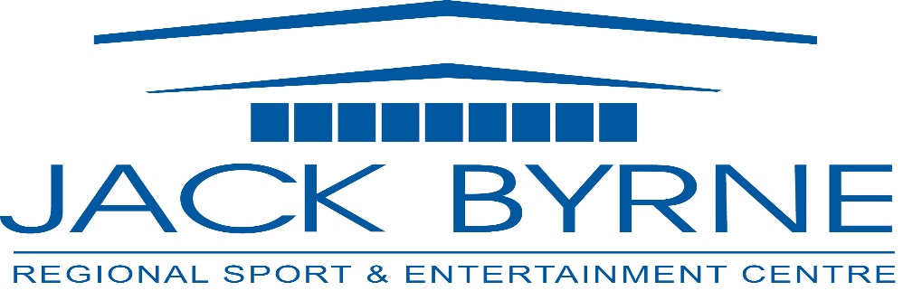
Jack Byrne Regional Sport & Entertainment Centre
Minutes-
Board Meeting- October 19th, 2023

In attendance: Shannon Power (Chair), Mark Vardy (Vice Chair),Tony Pollard (Treasurer), Laurie Furlong (Secretary), David Hearn, Terry Edwards
Regrets: Darrin Thorne, Ward Gosse, Terry Humber, Tony Palmer

- Meeting called to order 6:59 pm- Shannon Power

- Adoption of Minutes from March 28th, 2022 meeting
No errors or omissions noted
Moved by David Hearn, seconded by Tony Pollard

- Business Arising

- Strategic planning-
Cathy to book a half day session with Tom on a Thursday

- Financials to September 2023
Discussion ensued, no concerns noted.

Move to accept financials by David Hearn, seconded by Tony Pollard

- Budget 2024 Update

- Patron Removal Update- Everyone Currently happy with the resolution on both sides on how situation was addressed.

- Vending Machines :

- Kids have been robbing the candy machines
- Safety Concern for Senior’s Hockey
- Cathy to review if contract in place, potential removal if not.

- Wrongful Dismissal Update- Cathy, Shannon and David went on a call, there was no response after the fact.

- NEMHA President Recurring Meeting- meetings will be formalized quarterly.

- Advertising Update-

- Browning Harvey updated Logo for sign, new font approved by majority of vote.
- Terry and Laurie to meet next week.

- Operational Update-
Discussion ensued on below items, no concerns or objections noted.

Maintenance Update
The following maintenance has been completed:
- All painting – community room, dressing rooms, front foyer, hallways (under bleachers)
- General repairs to dressing rooms and bathrooms
- Track has been scrubbed by an outside company at a cost of $3082
- Waste Oil has been removed at a cost of $1952
- Compressor #1 has been rebuilt by CIMCO, bearings and belts were replaced in Compressor #2 at a cost of $9432
- Repairs to the Olympia at a cost of $2033
- Digital Sign repairs cost $2300
- Battery Charger was installed for the new Zamboni at a cost of $4400
- Hoisting ropes replaced in elevator cost $1240
- A filter was placed on Well #1 (as previously approved) at a cost of $4653
- Transformer was replaced by NL Power in August at no cost to JBR

Future Maintenance
- Control Pro will be completing repairs to motors for Air Handling Units, and Exhaust Fan (on the roof) units - $10548
- CIMCO will be completing repairs on the condenser pipes (structure outside Zamboni room)-pipes are corroded. The system will be shut down for 1 day, we have it scheduled for Monday, November 6th. The cost is $7700
- CIMCO will be replacing the safety relief valves in the new year at a cost of $5875. This maintenance is government mandated

The new Zamboni was delivered in July and has been operating. Staff has also been using the Olympia to keep it functional.

Renewed Contracts
2 Insurance policies have been renewed, through MUNN Insurance.
Directors Liability $3267.15
Facility Insurance $43955 (received a quote from another insurance company, it was over $70,000)

Snow Clearing contract has been renewed with Murphy’s Ground Patrol for 2023-2024. The cost remained the same at $5600 per month, beginning December 1st.

Quotes
In addition to previously submitted quotes, Electronic Systems Group has supplied a quote to replace the mixer in the sound room. The cost is $1950
Additional repairs, including replacement of amplifiers will be required after this is completed.
If this work is completed, we should look into having a cover placed over the mixer to ensure it is not damaged.

Majestic Metals submitted a quote for installation of snow fence on the front entrance and the curved portion of the roof (in front of the community room). The estimated cost is $22,800

Ice Rental Agreements
Ice Rental Agreements were sent to all user groups in late August. There was an increase of $5.00/ hour across the board.
All groups returned, with the exception of one (Saturday at 9:00pm). We have added a second high school game at this time.

Special Events Update
2023
November 7- 12: NL Craft Council Christmas Fair
November 29- December 3: North Pole Christmas Fair

2024
2024 is shaping up to be a busy year.
Easter is early, bringing the possibility of Minor hockey tournaments April 1-6
Returning off- ice rentals include Atlantic Grocery, Milestone Promotions, NL Construction Association, Two Guys Motorcycle Training and Thomas Amusements
New rentals include Holy Trinity Prom, MUN Engineering Dinner/Dance, Energy NL Reception, Holy Heart Prom, and Gonzaga Cap & Gown.
Hockey Camps already are already booked from July 1 through August 30

- Employee Agreement:
Reviewed Current Document, agreed to renew with proposed wage increase suggestions to update language
Review with an Employment Lawyer to ensure all is coacher.

- Board Chair Term and Transiotion:4 Shannon Power’s term complete, Chair Role Moving to Mark Vardy (Pouch Cove)

- New Board Members/Expiring Terms:
- Shannon Power’s term complete, Chair Role Moving to Mark Vardy (Pouch Cove)
- Terry Edwards, term complete, position will be taken back to LBMC council for a new Community Representative

- Other Business –

- Received Letter from HTH Principal requesting time change with school dismissal change in 2024/2025. Will Review if possible, only with current group in that slot open to a slot swap.
- Best Kind Comedy Show by Pouch Cove was a great success, it would be great to get more community events on the books.

- Next Meeting: January 16th

- Meeting Adjournment at 8:16 PM

Moved by David, seconded by Terry.

