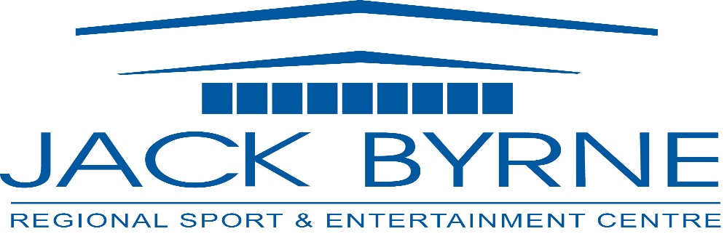
Jack Byrne Regional Sport & Entertainment Centre
Minutes- DRAFT
Board Meeting- March 7th, 2024

In attendance: Mark Vardy (Chair), Tony Pollard (Treasurer), Laurie Furlong (Secretary), Chris Roche, Tony Palmer, Rhonda Manning, Darrin Thorne
Regrets: Shannon Power, Terry Humber, David Hearn

- Meeting called to order 7:04 pm- Mark Vardy

- Adoption of Minutes from March 28th, 2022 meeting
No errors or omissions noted
Moved by Tony Pollard, seconded by Rhonda Manning

Business Arising

- Strategic plan update- Motion to review and discuss next meeting, Tony Pollard, seconded Darrin Thorne
- Vending Machines- Motion to remove Candy Machines, Darrin Thorne, seconded by Tony Pollard

- Board of Directors- Fill positions
  - Executive, Call for another Director to take over the Secretary role, due to Laurie accepting a new position. To be revisited next meeting.
  - Vice Chair, currently vacant. To be revisited next meeting.

- Financials to January 2024
Discussion ensued, no concerns noted.
Suggestions for revenue increase: increase bar prices in September 2024
2% recovery charge on invoices paid with credit card, beginning September 2024; must be disclosed on invoices and statements.

Move to accept financials by David Thorne, seconded by Tony Palmer

- Budget 2024 Update
Discussion ensued, no concerns noted

- Advertising Update- New Signage in place

- Operational Update-
Discussion ensued on below items, no concerns or objections noted

Maintenance Update:
The following maintenance has been completed:
Pipes on Condenser have been replaced $9867.00
Bio Green system inspected $3105.00
Scrubber ordered & received $6385.00
PA System board replaced $1935.00
Electric Motor & Pump $3300.00
Maintenance on systems, water meter was temporarily placed
Compressor belts replaced $2482.00
Olympia repairs- brakes were replaced $1973.00
Gate threshold & safety pads replaced $2055.00
Zamboni repairs- sprocket & chain replaced $729.00
Exhaust fans on EHC/HRU - 1 replaced $6555.00
Hot Water Boiler $6000.00

Additional maintenance to be completed:
Safety valves to be replaced on refrigeration system
Parking Lot line repainting
Exhaust fans on HRU – 2
Repair and maintenance of dressing rooms, and community room

ACOA Meeting: A meeting with representatives from ACOA and Cathy has taken place.
While there is no Recreation Infrastructure program available at this time, they suggested the creation of a report of “non- recreation specific” items that will need to be replaced or purchased to continue the economic spin offs of special events.

Quotes: Request for quotes to replace the current security camera system, and install additional cameras. To be reviewed and discussed at later date

Electronic Centre Ltd $10,054.00 +tax
Boom IT waiting for final quote
Tucker Solutions $21,022.62 +tax

Off season: We are expecting to have the ice removed from May 13 until June 27. During this time we will have a collection of special events, including 2 tradeshows, market, 3 graduation dinners, 3 Cap & Gown Ceremonies and a concert. Required maintenance will take place during this time as well.

Professional Development: All staff have completed or are in the processing of completing professional development. The required safety courses include First Aid, Forklift, Scissor Lift, Fall Protection. Additional modules include Thinking Critically and Respectful Workplace

- New Board Members- Expiring Terms
Rhonda Manning has replaced Ward Gosse, we thank Ward for his time on the board over the years.
Laurie and David’s two year’s will be up in November, will need to bring forward to Torbay Community for new Community reps at that time.
As noted, Laurie’s Secretary Role will need to be filled.

Flatrock/Pouch Cove- Terms to be looked into for current members

Next Meeting: June 13th

Meeting Adjournment at 7:50

Moved by Darrin, seconded by Tony.

